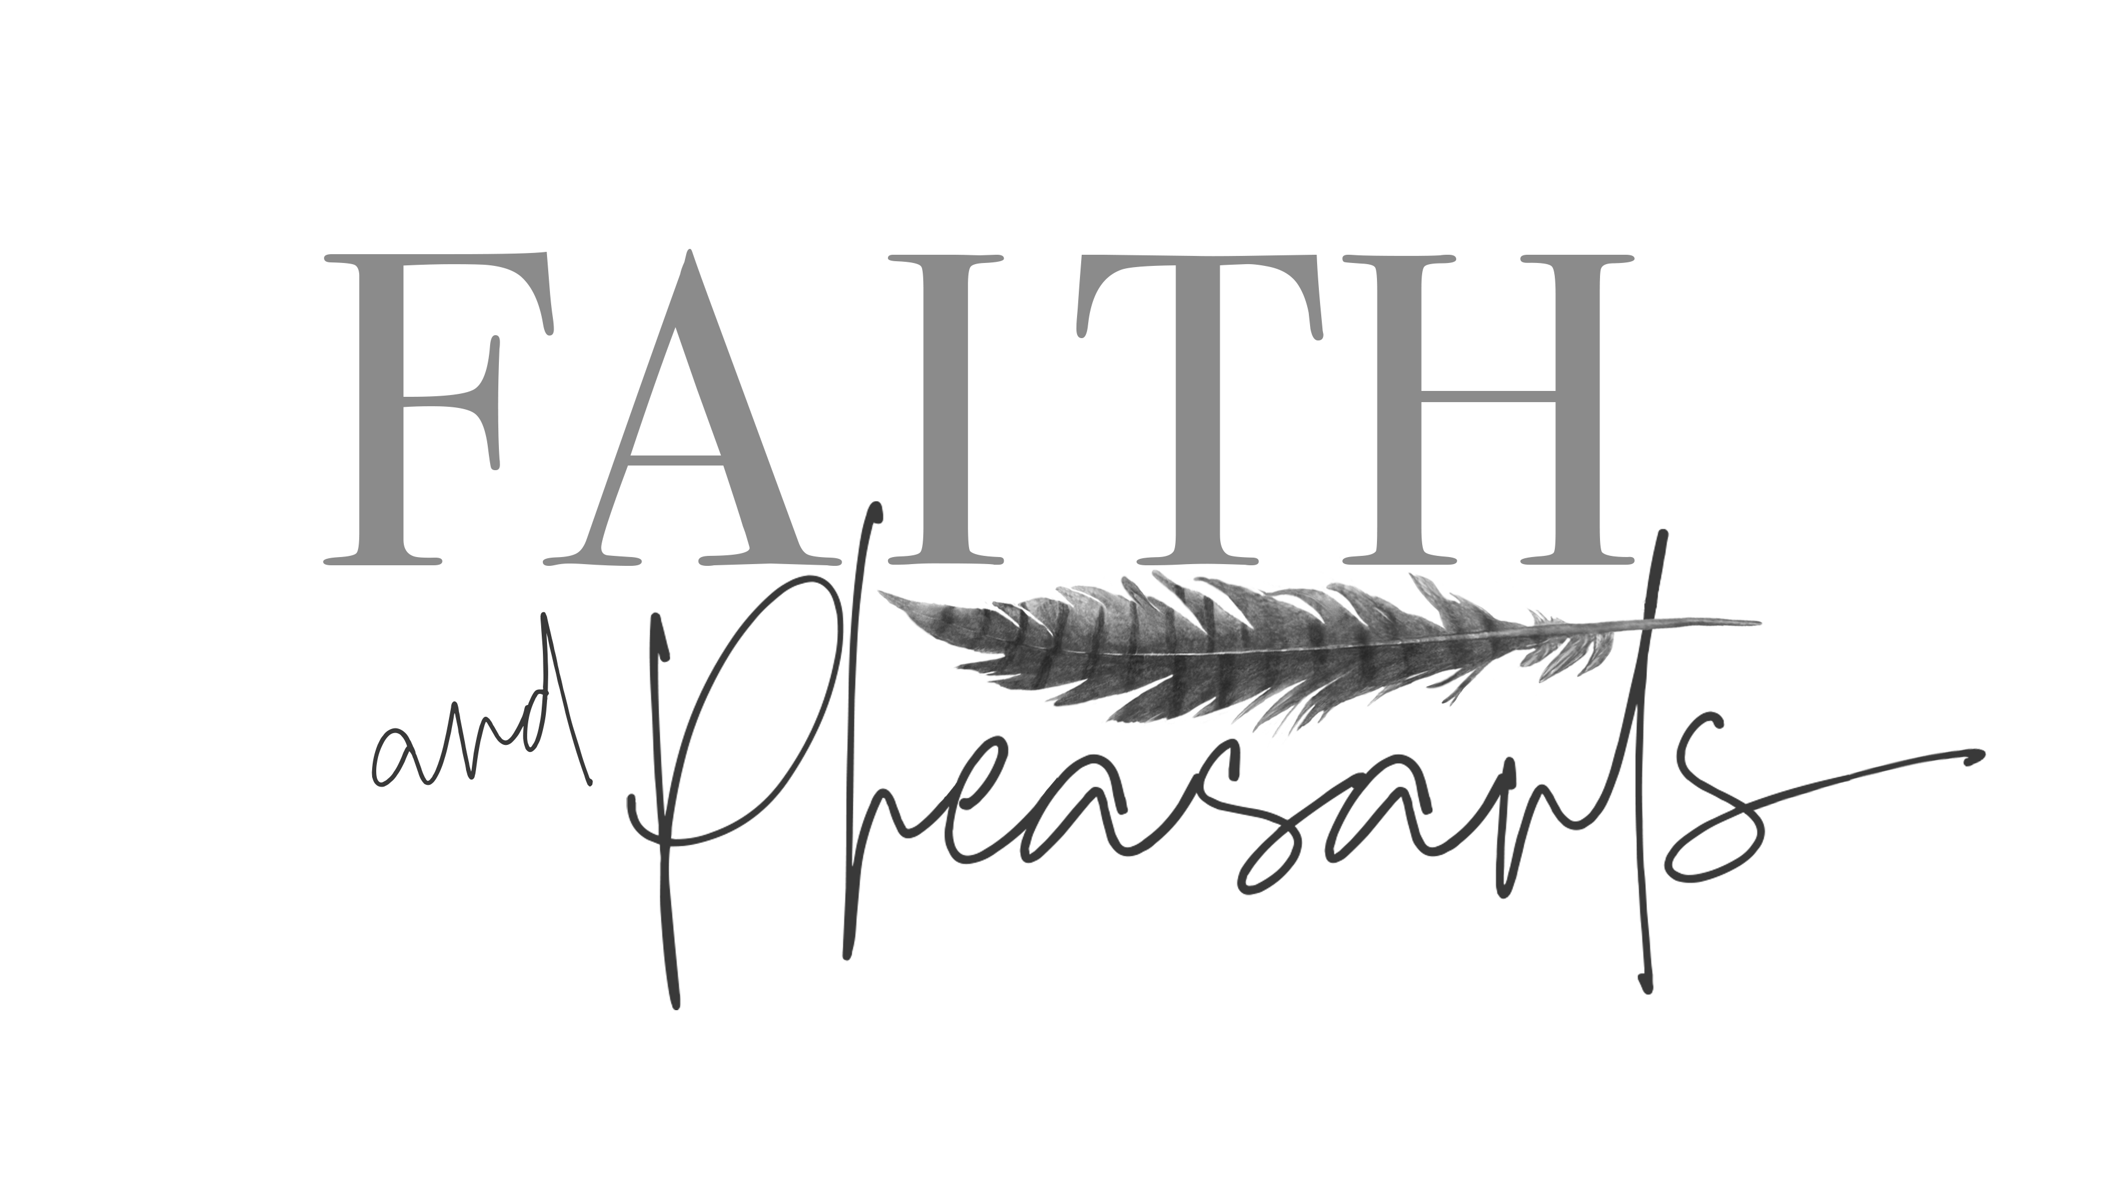

DIRECTIONS

Clear Creek Upland Game Lodge is located 4 miles south of Bartlett NE on HWY 81

Turn West on road 828

Look for the Faith and Pheasant signs

Drive approximates 1/2 mile till you reach lodge

Road dead ends into the lodge

**Women’s Retreat $950 Hunters $450 Non-Hunter**

**(Paid upon registration)**

Date: Sept 30, Oct 1 & 2 2022

Time: Noon Friday till Noon Sunday

Where: Clear Creek Upland Game Lodge

Bartlett, NE

***All Skill Levels are Welcome***

***Must be 21 to attend***

**RETREAT INCLUDES THE FOLLOWING:**

Two nights lodging

All meals and refreshments

Professional Guides and Trained Dogs

Bird Cleaning and prep to take meat home

Gun Safety and Instruction

Blue Rock Shooting (trap shooting)

**NOT INCLUDED:**

Travel cost to and from event

Two-day non-resident NE hunting license $92.00 (bought at the lodge

Ammo